International Symposium on Wildlife Diseases Research Network (WDRN)
(First Circular)

In the 21st century, the human society is facing serious threat and challenges of infectious diseases under accelerated climate change and intensified human activities. A majority of emerging or re-emerging infectious diseases in humans is originated from wild or domestic animals, and in return imposes a big threat to biodiversity conservation and livestock production. In order to have a better prevention and control of zoonotic diseases, it is crucial to understand the complex interaction patterns of disease transmission between humans, animals, vectors and pathogens under the rapid change of climate, other drivers of global change, and society by following a “One Health” approach. At the same time, world collaboration is essential to manage zoonotic diseases because animals, vectors and pathogens move freely in the world without boundaries.

Wildlife diseases are significant components of zoonoes, and they are playing increasingly important roles in causing pandemics of infectious diseases in recent decades. As compared to diseases in humans or domestic animals, wildlife diseases are poorly studied due to the vast diversity of their pathogens, hosts, vectors and habitats as well as global shortage of investment for research. Thus, there is an urgent need to strengthen the capacity of research on wildlife diseases, and international collaborations, in order to promote the prevention and control of zoonotic disease for a heathy world for both people and wildlife.

The International Society of Zoological Sciences (ISZS, http://www.globalzoology.org.cn/) is a non-government organization aiming to promote international cooperation in field of zoology by integrating multiple disciplines covering animals, plants, microorganisms, climate change, and human activities. To promote international collaborations on studies of wildlife diseases, and to bridge the gaps in prevention and control of diseases of humans, domestic animals and wild animals, ISZS is developing a Wildlife Diseases Research Network (WDRN) in the world, with collaboration of its partner such as Working Group on Zoonotic Disease (WGZD) of International Union of Biological Sciences (IUBS) (https://iubs.org/). WDRN is composed of a steering committee, a scientific committee, research expert network and collaborative partners. WDRN will hold annual symposia, workshops, training courses and publish an annual report on wildlife diseases. With support from the WDRN’s expert teams and its partners, WDRN aims to build a database and information center to facilitate the research, monitoring, prevention and control of wildlife diseases around the world. WDRN is devoted to work with IUBS, WHO, WOAH (OIE), FAO, and other organizations to promote prevention and control of zoonotic diseases in the world.

ISZS is going to hold the first International Symposium on Wildlife Diseases Research Network (WDRN) on June 26-28, 2023 in Haikou, Hainan province of China. The WDRN symposium will be held in both on-line and off-line formats. There will be a post-tour of visiting a national geographic park on June 29. The symposium’s topics related to wildlife diseases or zoonotic disease include:
(1) Genomics and coevolution of hosts, vectors and pathogens
(2) Disease transmission across species
(3) Impact of climate change on disease prevalence
(4) Influence of biological invasion on disease transmission
(5) Influence of migration of animals or their products on the disease transmission
(6) Impact of biodiversity loss on disease transmission
(7) Identification of hosts, vectors and pathogens
(8) Network construction and analysis of disease transmission
(9) Monitoring and surveillance of hosts, vectors and pathogens and their habitats
(10) Prevention and control of disease transmission
(11) Diagnostic reagents, vaccines, drugs and related equipment
(12) Others

The WDRN symposium is co-organized by ISZS and IUBS, hosted by Hainan University, assisted by the Institute of Zoology (IOZ), Chinese Academy of Sciences, and sponsored by China Association of Science and Technology (CAST) and Chinese Academy of Sciences (CAS).

On behalf of the organizing committee, we warmly invite you to attend the WDRN symposium and join in the cooperative network. The online registration fee is zero, off-line (onsite) registration fee is 300$ per person (Appendix 1, half for students or ISZS members; zero for one person who contributes one chapter for the Annual Report on Wildlife Disease or paper for INZ special issue, see below; zero for symposium organizers and speakers with oral presentation). For registration, please fill the Appendix 2 and send it to Dr. Hongjun Li (lihj@ioz.ac.cn) before the deadline of May 15, 2023. The WDRN symposium will be held in the International Academic Exchange Center, Hainan University. The venue and transportation information are shown in Appendix 3. The organizing committee of WDRN can help participants (who have paid the reregistration fee) to reserve a hotel room (350 or 450 Chinese Yuan per night) in the International Academic Exchange Center, Hainan University before 15th May, 2023 (Appendix 2).

For those interested in organizing a session (6-8 people for each session for a half day), or giving an oral presentation (20 minutes plus 5 minutes discussion, PPT 16:9) or posters (for details, see Appendix 4), please submit your abstract (for details, see: Appendix 5) and speaker’s information to Dr. Hongjun Li (lihj@ioz.ac.cn) before the deadline of May 15, 2023. For online oral presentation, pre-recorded video is needed (for details, see Appendix 6), which should be sent to Dr. Hongjun Li before the deadline of June 15, 2023.

WDRN is calling for experts to write the 2022 Annual Report on Wildlife Disease. The annual report will consist of 10-20 chapters, and each chapter has about 3000-5000 words plus figures, photos, tables, pictures. Each chapter should focus on key wildlife or zoonotic diseases in a key region or the world in 2022, and give a whole picture about prevalence of zoonotic disease, transmission route, hosts and vectors, damages and losses, influencing social or environmental or climatic factors, prevention and control measures, and suggestions for early warning or prevention of coming years. The deadline of submission of the report is May 30, 2023. The annual report will be released in our website (linking with those of our partners). Once the annual report is accepted, a financial support package (registration fee, hotel fee and round-trip economy class air-ticket) will be made available to the lead author (only one person) attending the WRDN meeting in 2023 or next years, or the International Symposium of Integrative Zoology (ISIZ) held annually, or the International Congress of Zoology (ICZ) held every four years in different parts of the world. For details, please see Appendix 7, and contact Mrs. Wenhua Xiong (xiongwh@ioz.ac.cn).

Integrative Zoology (INZ, https://onlinelibrary.wiley.com/journal/17494877) is going to publish special issues from selected papers contributed in the WDRN symposium (see Appendix 8). For those interested in submitting a paper to INZ, please contact with Dr. Wenhua Xiong (xiongwh@ioz.ac.cn). The deadline of submission of the report is May 30, 2023. For those with a paper being finally accepted, a financial support package (registration fee, hotel fee and round-trip economy class air-ticket) will be available for one author attending the WRDN meeting in 2023 or next years, or the International Symposium of Integrative Zoology (ISIZ) held annually, or the International Congress of Zoology (ICZ) held every four years in different parts of the world.

We look forward to your attendance and contribution to the Symposium on Wildlife Diseases Research Network (WDRN)!

Yours sincerely,

Organizing committee of WDRN
Contact info:
Secretary of WDRN
Dr. Hongjun Li
Email: lihj@ioz.ac.cn

Appendix 1. Payment (completed before May 15, 2023)
You can pay your registration at the Registration Desk or through bank transfer. The information on bank transfer appears as below:

Bank name: BANK OF CHINA BEIJING MIDDLE NORTH FOURTH ROAD SUB-BRANCH
Bank address: 1-2/F, Tower Pangu Building, Middle North Fourth Ring Road, Chaoyang District, Beijing, China
Name of the bank account: International Society of Zoological Sciences
Bank account number: 324656829425
Swift code: BKCH CN BJ 110
Bank telephone number: +86-10-59393301

Note: You must notify the Secretariat after your fund transfer at: iszs@ioz.ac.cn or fax: +86-10-64807295

Appendix 2. Attendance information (send it to lihj@ioz.ac.cn before May 15)
Name
Country/region
Gender
Nationality
Institution
Contact address
E-mail
Phone
Flight information (Flight number and date)
Hotel booking (International Academic Exchange Center, Class A room: 350 RMB/room/night; Class B room: 450 RMB/room/ night)
Visiting Crater National Geopark (Yes or No)
Special requirements
The deadline of hotel booking is 15th May, 2023. The participants need to pay the fee of 1 night, if they cancel the booking after 22nd June, 2023. The visiting for Crater National Geopark will be held on 29th June, 2023. The details for the visiting is shown in Appendix 11.

Appendix 3. Meeting venue, hotel, meal and transportation
International Academic Exchange Center, Hainan University locates at the east gate of Hainan University (No. 58, Renmin Avenue, Meilan District, Haikou City, Hainan Province), about 29 kilometers from Meilan International Airport, about 12 kilometers from Haikou East Railway Station, and about 25 kilometers from Haikou Railway Station. The participants can arrive at the hotel by self-driving, taxi or by the following public transportation:
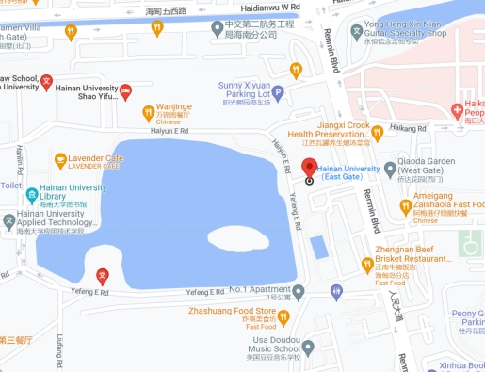
Hotel Reservation
Class A room: 350 RMB/room/night
Class B room: 450 RMB/room/ night
The participants need to book rooms and return the information to organizing committee via the receipt (Appendix 2) before 15th May, 2023. The participants need to pay the fee of 1 night, if they cancel the booking after 22nd June, 2023. The participants can also book rooms via the phones below: Mr Zheng +86-13876749397, or Mr Liu +86-13518840053. Please note “WDRN symposium” when book the rooms. Please note your hotel reservation to Dr. Ming Liu (liuming@ioz.ac.cn)

Meals:
Lunch (buffet) 80 RMB/day
Supper (buffet) 80 RMB/day
Dinner (round table) 200/person
Note: Registration fee covers the above meal cost.

Transportation
From Meilan International Airport, the participants can choose to take Airport 3/Airport 2 → 44/41 or Airport Bus 1 → 44/41 to International Academic Exchange Center, Hainan University.
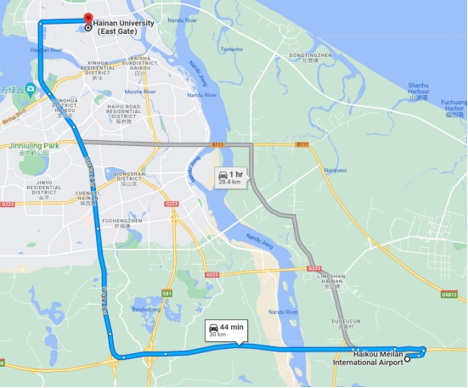
From Haikou East Railway Station to the International Academic Exchange Center, the participants can take Bus Line44/41/G90.
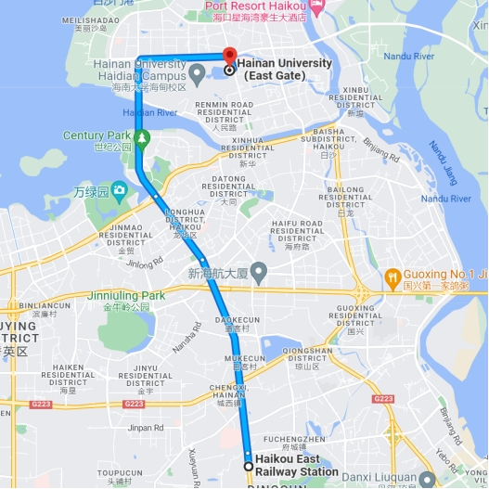

From Haikou Railway Station to the International Academic Exchange Center, please take Suburban Railway S8099/Suburban Railway S8037/Suburban Railway S8101 → G54 or Suburban Railway S8099 → Line15.
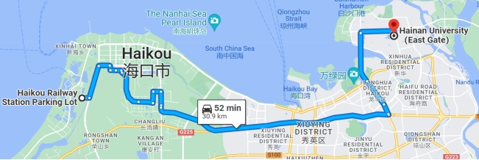

Appendix 4. Poster
The poster size is 120 cm in length and 80 cm in width.

Contact: Dr. Hongjun Li (lihj@ioz.ac.cn)

Appendix 5. Abstract

Title of the abstract (Times new roman, Bold, 14pt)
Authors and Affiliations (Times new roman, Regular, 10pt) should be placed before the contents of the abstract, such as:
One Liu¹, Two Liu², Three Liu^{3,*}
1. Institute of Zoology, Chinese Academy of Sciences, Beijing, China.
2. Institute of Biology, Chinese Academy of Sciences, Beijing, China.
3. University of Zoology, Chinese Academy of Sciences, Beijing, China.
*: Correspondence to Three Liu (Liu3@aaa.ac.cn)
The abstract (Times new roman, Regular, 12pt) for the International Symposium on Wildlife Diseases Research Network should be up to 250 words in one paragraph WITHOUT figures, photos, tables, or pictures. Deadline of submission is May 15, 2023.
Key words: (2-5 key words, Times new roman, Regular, 12pt, less than 250 words)

Contact: Dr. Hongjun Li (lihj@ioz.ac.cn)

Send it to Dr. Hongjun Li before May 15 2023.

Appendix 6. Pre-recorded video
The format of pre-recorded video is MP4, less than 50MB.

Contact: Dr. Hongjun Li (lihj@ioz.ac.cn)

Appendix 7. Annual report

Title: Transmission, prevention and control of xxxxx (key zoonotic diseases) in 2022 in xxxx (key regions)

Background
International Society of Zoological Science (ISZS, http://www.globalzoology.org.cn) is going to build a Wildlife Diseases Research Network (WDRN), including activities of holding annual symposium and publishing annual report on situations of wildlife diseases in the world. Through WDRN, ISZS will work together with IUBS (and its Working Group for Zoonotic Diseases, WGZD), WHO, OIE, and other partners to promote research on wildlife diseases, aiming to bridge the gap between studies of human, domestic and wild animal diseases.

Contents of annual report
The annual report on zoonotic disease is about 3000-5000 words plus figures, photos, tables, pictures. Each report should focus on key zoonotic diseases in a larger region in 2022. The report should give a whole picture about prevalence situations of key zoonotic diseases, transmission routes, major hosts and vectors, environmental or climatic factors, infections or damages to human health, prevention and control measures, and suggestions for early warning or prevention. The annual report will be released in the website of the International Society of Zoological Sciences (http://www.globalzoology.org.cn). Deadline of submission: May 30, 2023.

Outline of the report
- Introduction
- Prevalence of key zoonotic disease
- Factors affecting transmission
- Measures of prevention and control
- Future trends and suggestions

Format
For the format, you can refer to the related articles and author guidelines at: https://onlinelibrary.wiley.com/doi/toc/10.1111/(ISSN)1749-4877.zoonotic-infectious-diseases

Contact: Dr. Wenhua Xiong (xiongwh@ioz.ac.cn)

Appendix 8. Special issue
For the format, you can refer to the related articles and author guidelines at: https://onlinelibrary.wiley.com/doi/toc/10.1111/(ISSN)1749-4877.zoonotic-infectious-diseases

Contact: Dr. Wenhua Xiong (xiongwh@ioz.ac.cn)

Appendix 9. Insurance
All participants need to arrange their own medical insurance and accidental insurance.

Appendix 10. Weather information
The air temperature in June at Haikou is 26-33℃, with monthly precipitation 166mm.

Appendix. 11 Post-meeting trip
The local traveling agency will provide several field trips for choice by participants (e.g. Crater National Geopark on 29th June 2023). Participants can make a choice in the Appendix 2. More post-meeting trips will be available later. Participants are responsible for the payment of their post-meeting trips (more information will be available soon).

